**Method : Enabling Ubuntu on Windows 10**

**Enable Developer option in control panel**

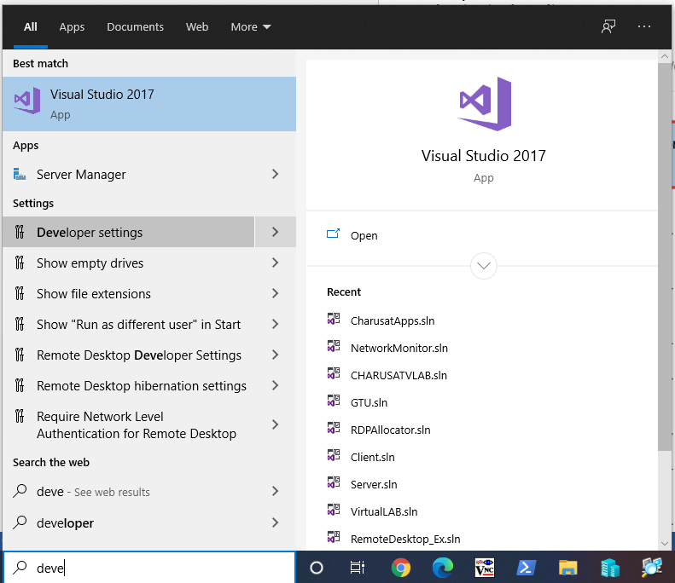

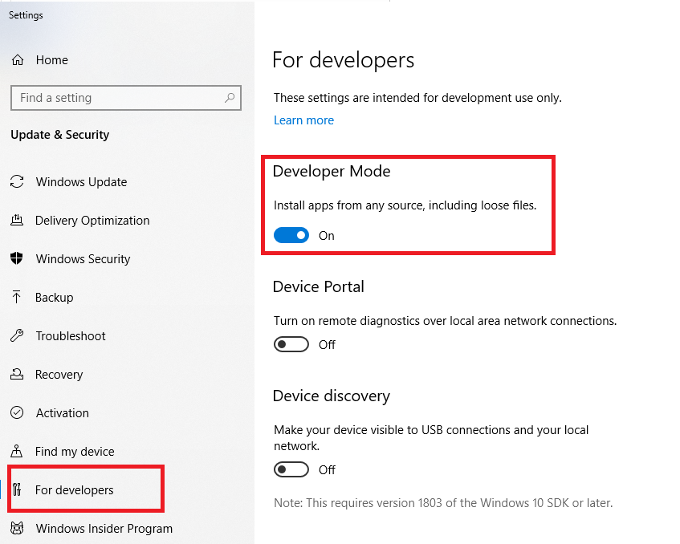

To use the *Windows Subsystem for Linux* to start up the Ubuntu terminal without setting up a virtual machine:

1. Open the **Start** menu and search for *Turn Windows features on or off*. Click on the shortcut when it appears.

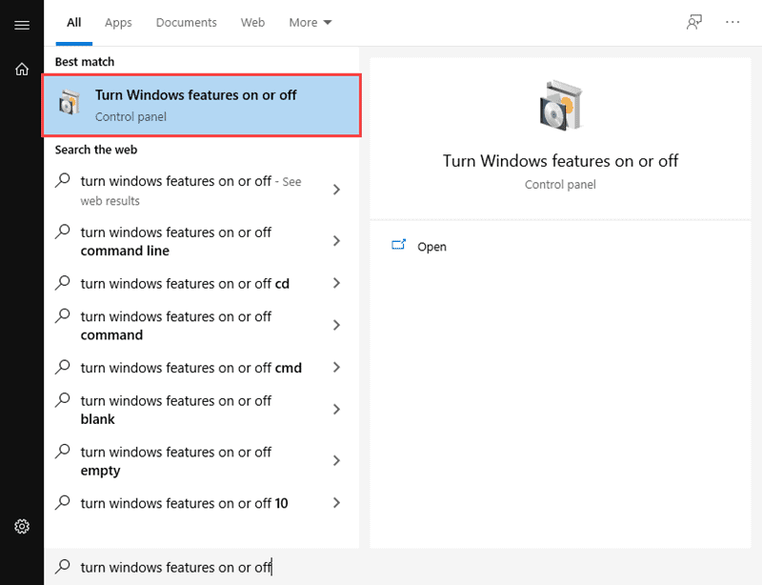

2. Scroll down through the list of features until you see *Windows Subsystem for Linux*. Click on the checkbox, and then click **OK** to enable the feature.

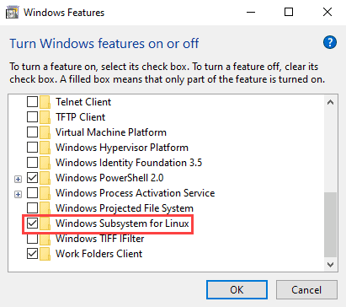

3. Open the Microsoft Store. Search for Ubuntu and click on **Get** to install the latest version.

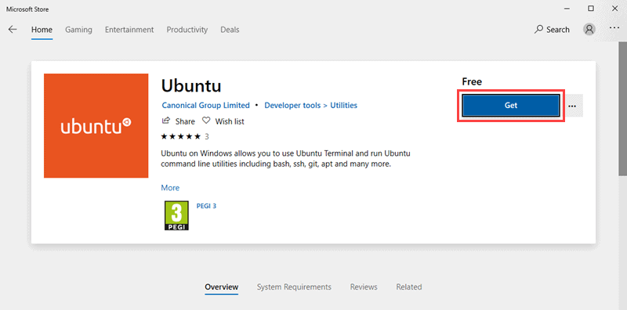

4. Once the installation is complete, click on **Launch** to start up the Ubuntu command terminal.

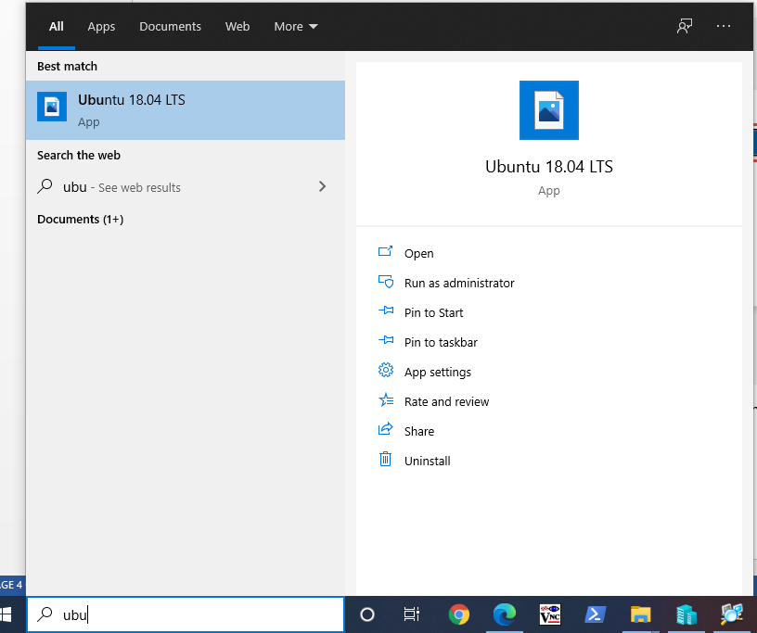

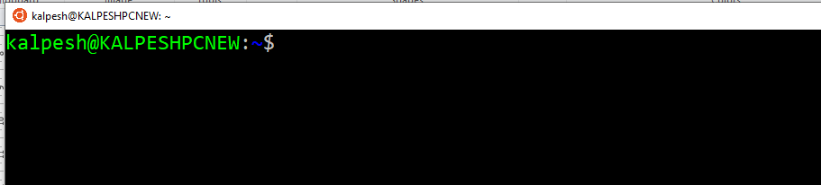

5. To install Ansible, enter the following set of commands:

$ sudo apt-get update

$ sudo apt-get install software-properties-common

$ sudo apt-add-repository ppa:ansible/ansible

$ sudo apt-get update

$ sudo apt-get install ansible -y

To use Windows as Client you have to install & enable winrm Module

* $ apt-get install python-winrm
* $ apt-get install python3-winrm
* $ apt-get install python-pip
* $ pip install "pywinrm>=0.3.0"

6. Enter Host & Authentification details in vi /etc/Ansible/host file

